# Current Activities

Curators have been focussing on two main activities; trying to bring more hardware that is on display back to life, and sorting out any excess machines (i.e. where we have more than 2) for disposal. We are also looking at potential new display items and potential rearrangements within the museum.

## Hardware Repair

#### signal-2024-05-09-110645_002_med.jpgTypewriters

We have successfully repaired one each of the three typewriter technologies:

* Typebar, using a model B
* Selectric
* Wheelwriter

These have been moved to our ‘touchy feely’ corner so visitors can see hands-on the technical progress of this now outdated technology, and also try them out. This should also make it easier to explain to the younger generations what a typewriter is.

The Selectric input / output typewriter from a 2741 terminal has been on the workbench for years. We thought the job was finally done, only to find that the keyboard keys were all slow to restore. The culprit has been identified; each keylever has a small pivoting spring-loaded bracket that pivots out of the way when a key is pressed, relieving the load on the return leaf spring. Every one of these is jammed solid, and can only be freed up by a combination of cleaning fluid and physically moving the bracket, which is virtually impossible in situ. We are now in the middle of extracting the keylevers and freeing them up. This could take some time!

#### 6580 - 008_med.jpgDisplayWriter

DisplayWriter was a dedicated word processing computer, released in June 1980, a little over a year before the IBM PC was announced. We have had one on display for many years, and previous attempts to get it working failed. Some time ago a 110V DisplayWriter system was donated, and using the system unit from this machine has enabled us to bring it back to life, The only 8” diskette we have is a diagnostic disk, so if by chance anyone has some word processing software we could copy we’d be most grateful.

#### Maintenance Device

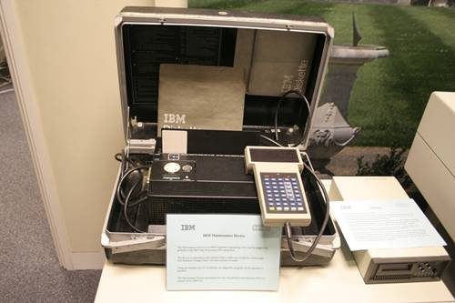Maintenance Device, or MD, was a portable diagnostic machine for the 3380 disk array and 3880 controller. Over the years we have collected quite a few of these. The only one that we know is working is on display, but without a 3380 there’s not much more we can do. We’re sorting through the remaining MDs so we can keep one of each of the two versions in the collection.

#### Personal Computer

Our PC-XT has been running constantly for quite a while, usually with the IBM Alley Cat game loaded. It surrendered a couple of weeks ago and has been replaced with a working spare for now till we get time to see if it’s repairable.

#### IBM and NASA

Following Dik’s appeal on behalf of the BCS magazine editor for help for an article about Computers in Space, we are now in contact with him, Martin Cooper. IBM’s relationship with NASA goes back to the very earliest times in the 1950s and has continued to this day. It’s difficult to see how the huge efforts can be netted down to a magazine article; perhaps we will need to concentrate on one programme, or take over a whole issue!

For example the Moon landing was supported by around 4,000 IBMers who built the computers, hardware and software to guide and track Apollo from liftoff to splashdown, and provided ground support with five S/360 Model 75s.

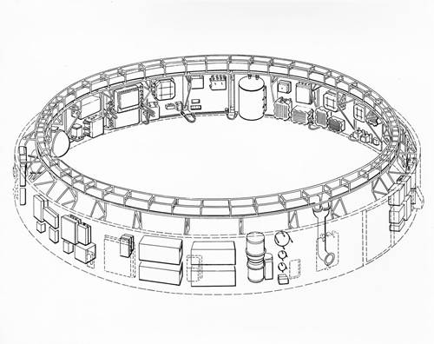The Saturn V Instrument Unit (IU), the top black ring on the final stage of the rocket, took over control from lift-off through Earth orbit to setting the correct course to the Moon. It managed everything from telemetry, speed, velocity and thrust to guidance, radio communications and emergency detection systems. The 2 ton, 21feet (6.4M) diameter by 3 feet (0.9M) high unit, lined with mission critical instruments, was designed and built by IBM. It had a MTBF of 40,000 hours and a component density of 250,000 per cubic foot or nearly 9 million per cubic meter, if my maths still works properly.

The new IBM Heritage area of the IBM website has several pages covering the space programmes. The Apollo page is <https://www.ibm.com/history/apollo> and you’ll find links to all the other space programmes and many other interesting pages on other IBM innovations and the company heritage via the Advancing Humanity tab.

None of this involved Hursley Museum, although one of our curators was involved with the Shuttle programme.

#### Museum Website

The museum website continues to attract an average of 11,000 page views a week.